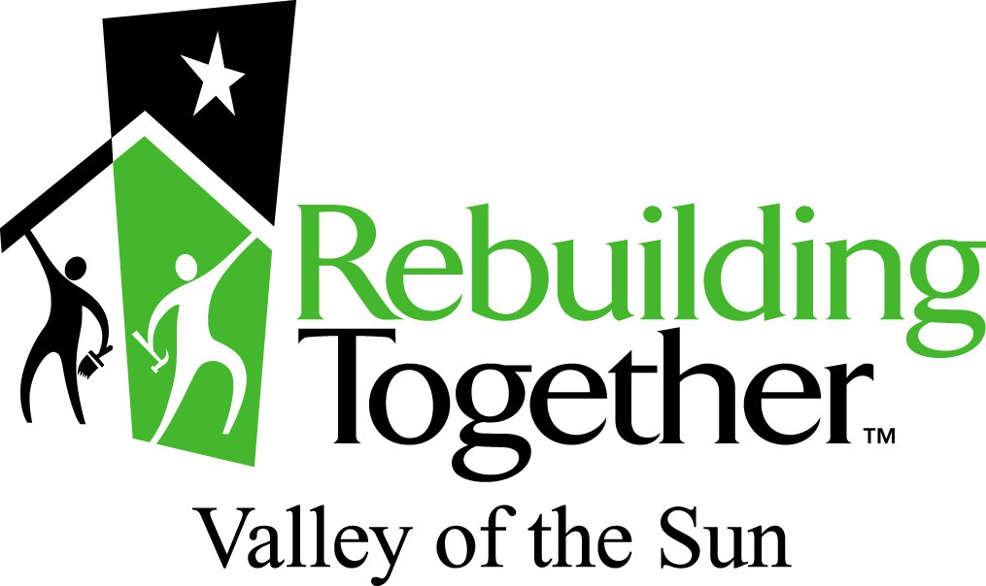

HOME SAFETY SERVICES

Rebuilding Together Valley of the Sun believes safe homes are key to healthy living and successful families. Working at the critical intersection of health and housing, we provide free safety modifications for low-income seniors, veterans and disabled individuals. Our work preserves healthy, safe, and affordable housing, facilitates comfortable aging-in-place, and enhances quality of life.

To apply for services, please submit the following:

- 3-Page Application

- Gross Income Verification Documents for each household member
(include as attachments)
Required income verification documents are:
    - Copies of previous three months’ bank statements
    - Copy of previous year’s income tax return
-AND- one of the following:
Copy of social security or disability award/determination letter, or
Copy of three most recent payroll check stubs
Please black out social security numbers and account numbers.

Three sources of income verification MUST be included with your application.
INCOMPLETE APPLICATIONS CANNOT BE CONSIDERED

Return applications via mail, fax or email to
Rebuilding Together Valley of the Sun
1826 W. Broadway Rd., Ste. 16
Mesa, AZ 85202
Phone: 480-774-0237
info@rtvos.org
www.rtvos.org

HOME SAFETY/FALL PREVENTION APPLICATION

Please check one: □ Mr. □ Mrs. □ Ms. Today's date: _________________________________

First Name: _________________________________ Last Name: ________________________________________

Address: ____________________________________________ City: _____________________________________

Zip Code: ___________ Date of Birth: _______/_______/________ Home phone: (______) ___________________

Cell Phone: (_____) ______________________ Email: __________________________________________

Are you a Veteran? _______________ Widow of a Veteran? _______________

Emergency Contact Name & Number: ____________________________________________________________

Are you filling out this application for someone else? Yes____ No, I am the applicant_____
- If yes, what is your relationship to the applicant_______________________________________________
- If yes, please put the names and numbers of the individuals we should contact regarding the application
Are you receiving any services (such as home health, have a caregiver, meals on wheels, etc.)? If so, please list name of service and frequency?
_______________________________________________________________________________________________

What is the best method to reach you? (Please circle one)
Email Phone Mail Other___________

Please list your height________ and weight________

PROPERTY INFORMATION
Do you own this home?□Yes □No Is this a mobile home? □Yes □No In what YEAR was this home built? _____

Race, Please CIRCLE one
White Black/African American Asian
American Indian/Alaskan Native Native Hawaiian/Other Pacific Islander Asian and White
American Indian/Alaskan Native & White Am. Indian/Alaskan Native and Black Black/African American
Black/African American and White Other Multi-Racial Prefer not to answer

Ethnicity: Please CIRCLE one
Hispanic/Latino Non-Hispanic/Latino Prefer not to answer

Rebuilding Together will not deny any services to people on the grounds of ethnicity, color, religion, national origin, gender or personal lifestyle.

INCOME How many people live in your home? ______ Adults _____ Children
Include income from all adults living in the home.
Amount of Gross Income Source of Income (for example, SSI, pension, wages, etc.)
$_________________________/year _____________________________________________
$_________________________/year _____________________________________________
Total Gross Income $_________________________/year

PLEASE NOTE: Submission of application does not guarantee service. Service fees may apply to those with incomes above 80% of the median. Program waitlist ranges from 4 weeks to 12 months, depending on program.

I/We certify that the above information is true and correct to the best of my/our knowledge. I/We realize that failure to provide all information requested could result in our application being invalid. I/We authorize RTVOS to check any references necessary to complete the processing of this application for the purpose of receiving housing rehabilitation through Rebuilding Together Valley of the Sun. I/We also understand that any information received will be kept confidential and will be used strictly for determining my/our eligibility for this program.

Signature(s) of Homeowner(s)

Date

Date

NEEDS ASSESSMENT
Do you use a wheelchair? Yes___ No___
- If yes, what type of wheelchair do you use? (Circle all that apply) Manual Power Scooter
or Other_____________
- Can you transfer to/from wheelchair without assistance? Yes___ No___
Do you use a walker? Yes___ No___
Do you use a cane? Yes___ No___
Safety/Accessibility/Disabilities: On a scale of 1-5, rate how you complete the following tasks using the scale below. Please circle one. (1- Unable to do independently, 2- Needs assistance most of the time, 3- Uses assistive device, 4- Occasionally needs help, 5- No assistance needed).

Can you get in and out of the tub/shower? 1 2 3 4 5

Can you use steps/stairs? 1 2 3 4 5

Can you get on and off the toilet? 1 2 3 4 5

Can you get in and out of bed? 1 2 3 4 5

Can you stand from a sitting position? 1 2 3 4 5

How many times have you fallen at home in the last 6 months? 0___ 1-3 ___ More than 3____

- If yes, where have your falls occurred? ______________________________________________________________________________________

- If yes, have you ever fallen at nighttime? Yes___ No___
In the last three weeks, how many times did you leave your home? 0-2 ___ 3-6___ 7-10 ____ More than 10____

- Are you currently still driving? Yes____ No___
Please check if you have any of the following:
Low Vision ____ Low Hearing _____ Arthritis_____ Neuropathy _____
Stroke _____ Amputee_____ TBI _____ Fractures_______
Other health concerns_______________________________________________________
How many smoke/fire detectors are there in your home? ________________
How many carbon monoxide detectors are there in your home? ___________
Does anyone in the home have asthma? Yes ___ No ___

SAFETY MODIFICATION LIST – check what is desired

□ Bathroom grab bars □ Toilet assistance (seat or handles)
□ Tub transfer bench □ Raised toilet seat
□ Hand-held shower sprayer □ Toilet side handles
□ Anti-skid safety mat □ Bathing seat
□ Bed Cane/Rail □ Smoke detectors
□ Nightlights

□ Ramp into home needed (priority given to people who can no longer easily get in/out of home)
(NOTE: We are unable to provide ramps inside homes or into sunken rooms.)

If you checked Ramp needed, please answer the following questions:
- Are there stairs leading to your home? Yes_____ No____
- If yes, please list how many steps? ____________
- What material are your steps made of? ___________________________________________________
- What entrance do you move most frequently? ______________________________________________

